**CSE3502-Information Security Management**

**LAB 6 – NAT (Network Address Allocation)**

**Name:** Eshan Das

**Registration Number:** 19BCE1575

**DATE:** 6th March, 2022

**TOPOLOGY IMPLEMENTED IN LAB**

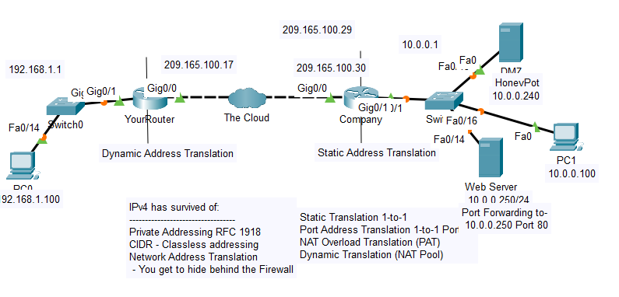

**NEW TOPOLOGY**

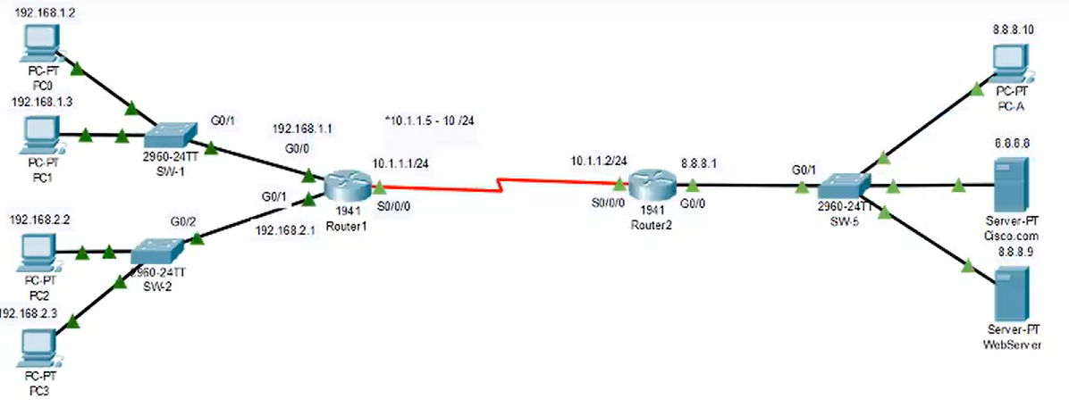

**PC configuration**

**PC0**

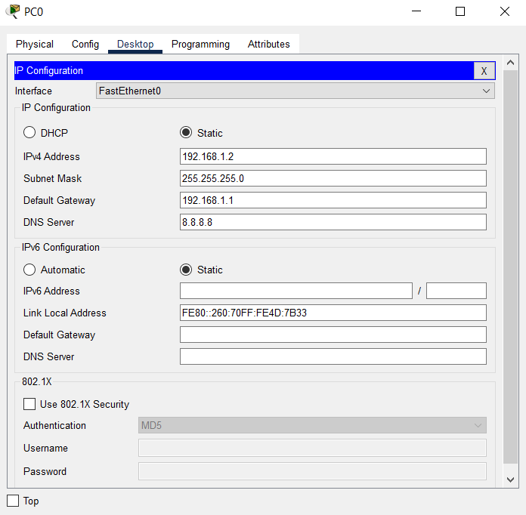

**PC1**

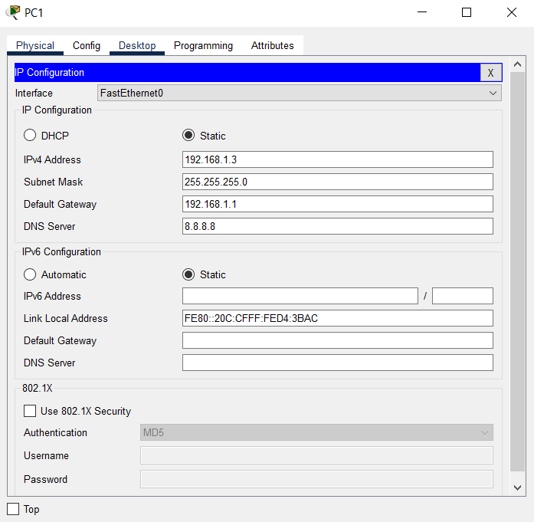

**PC2**

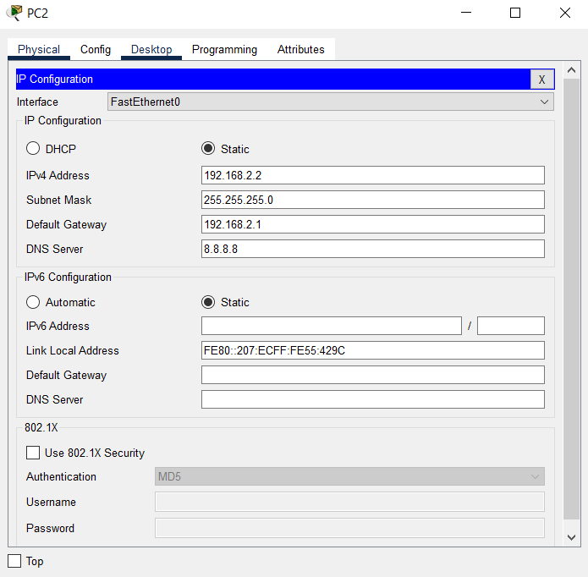

**PC3**

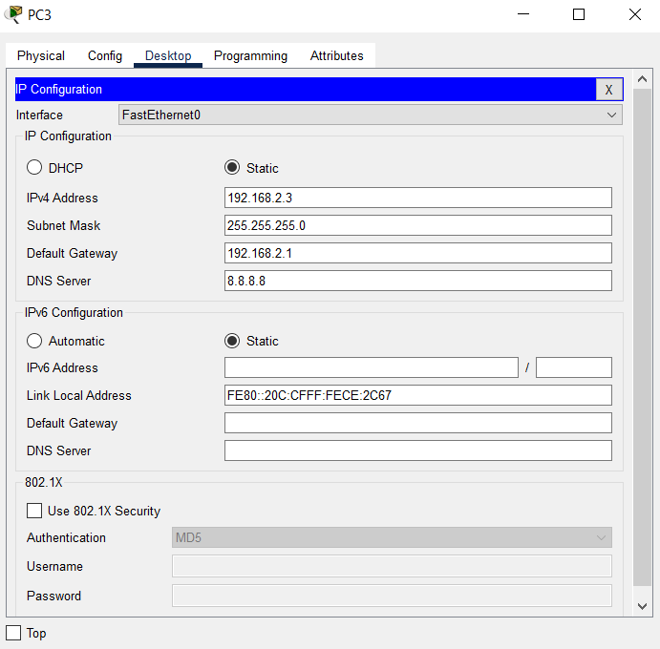

**WEB SERVER**

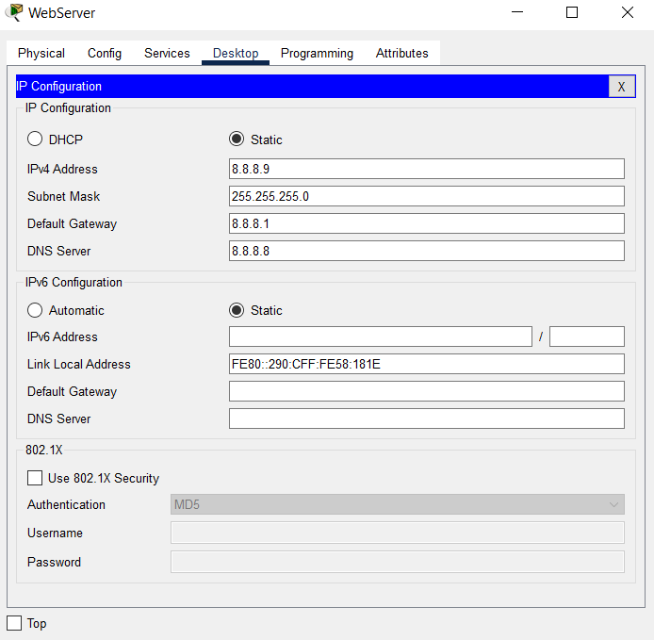

**CISCO.COM**

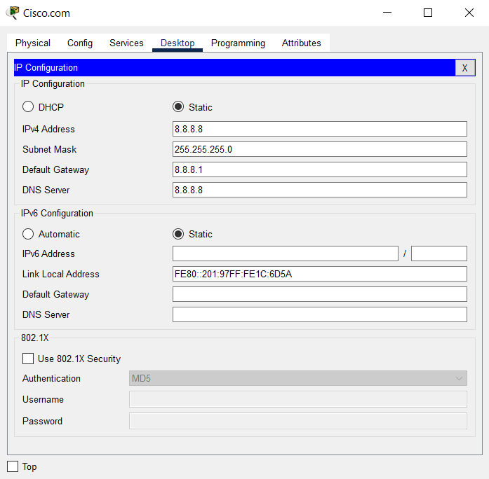

**PC-A**

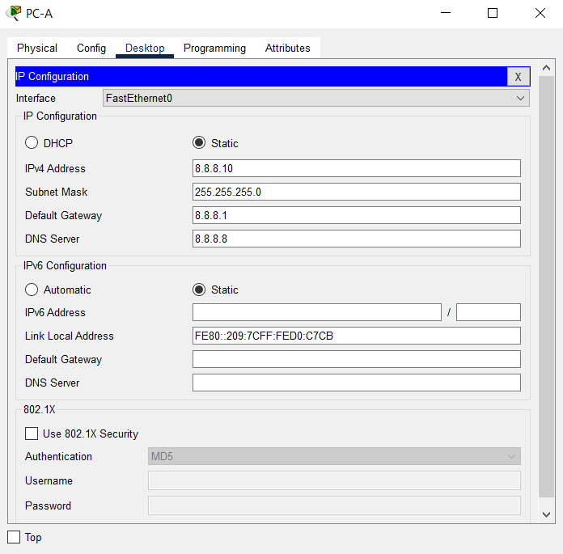

**CHECKING THE PING REQUEST**

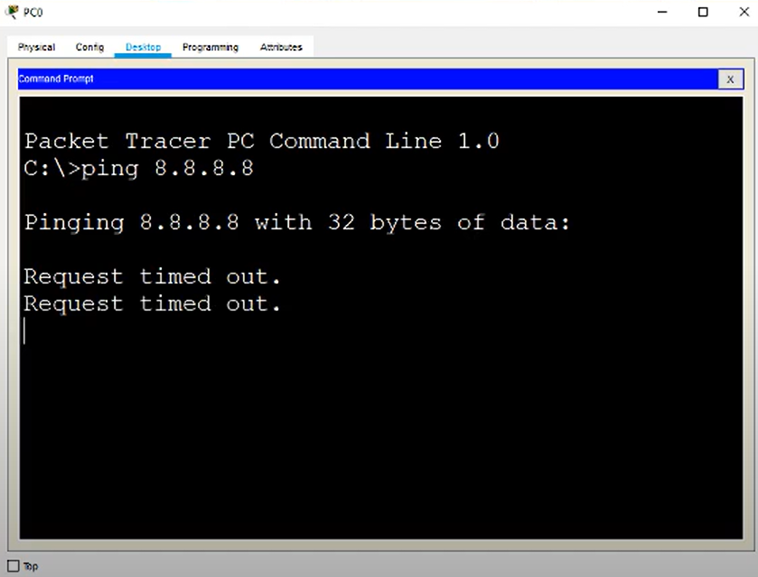

**Router 1941(for more switches) configurations**

**ROUTER 1**

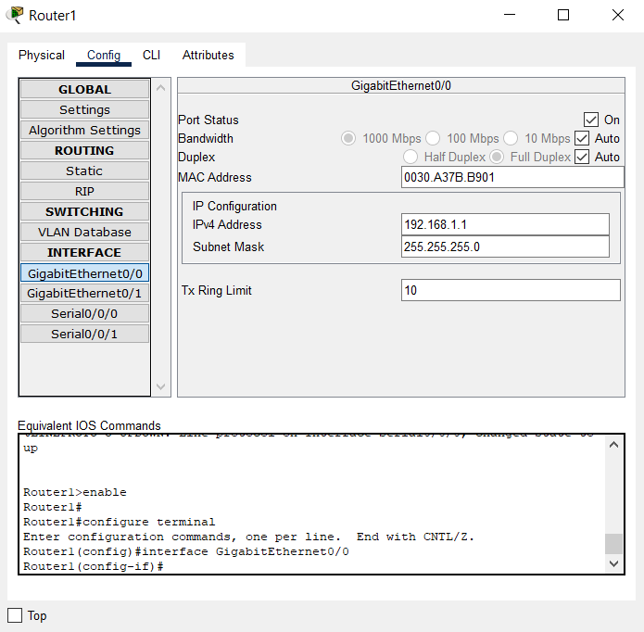

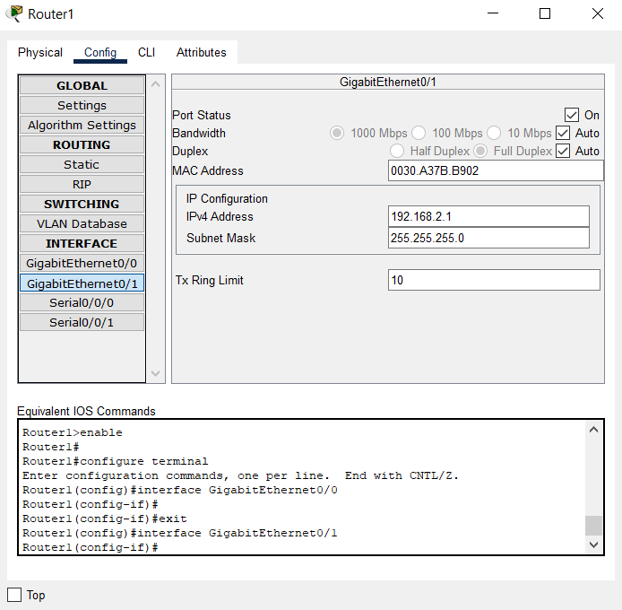

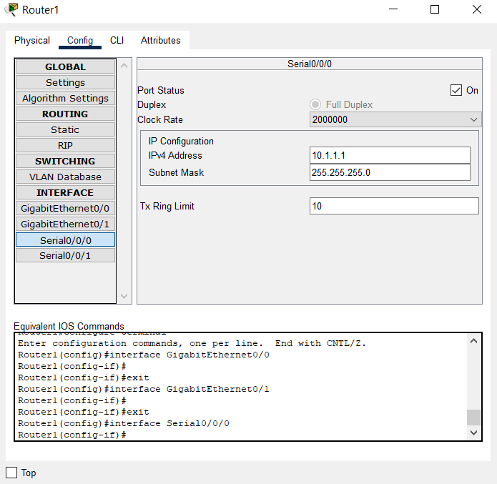

**ROUTER 2**

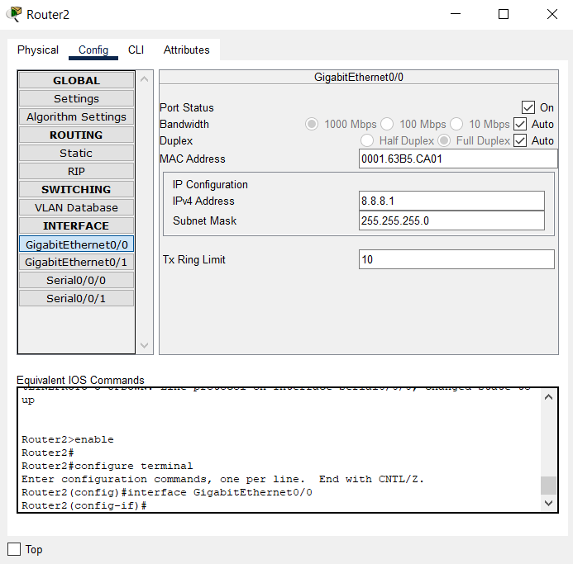

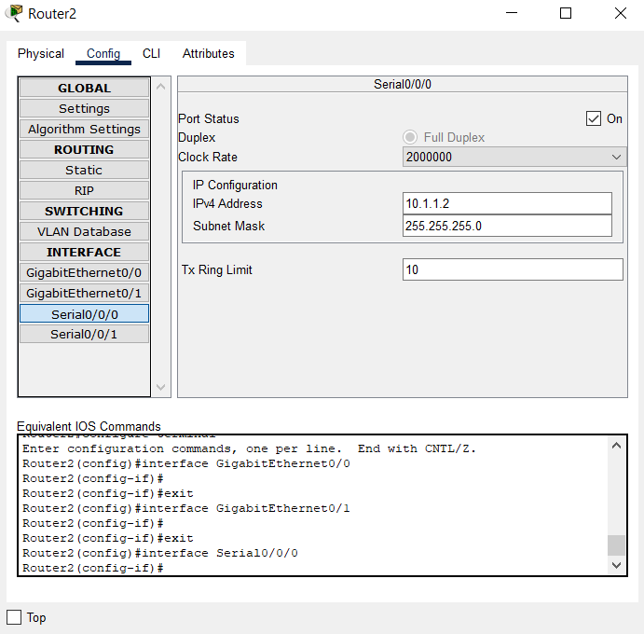

**STATIC NAT**

1. **NAT of cisco.com device using IP address of 10.1.1.3**

**Static translation**

Commands for static translation

First we mark interfaces as nat outside or nat inside and then using ip nat command to translate public ip address into a private ip address in our case for honeypot.

en

conf t

int g0/0

ip nat out

int g0/1

ip nat inside

ip nat inside source static 192.168.1.2 10.1.1.3

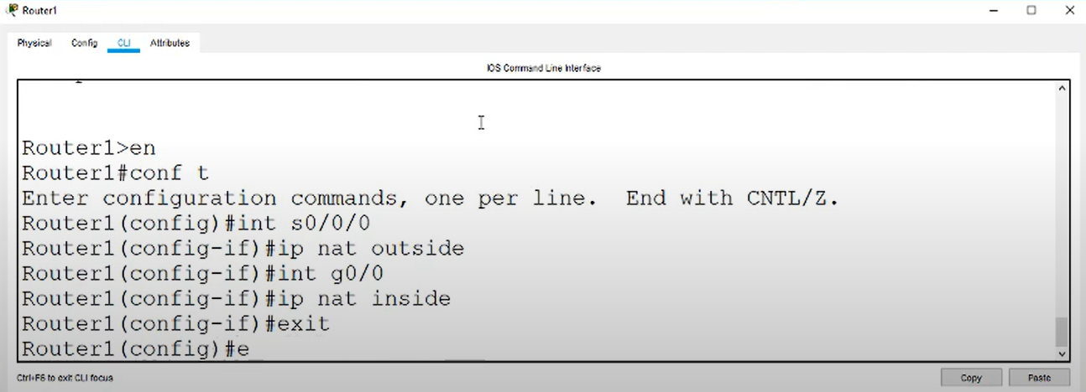

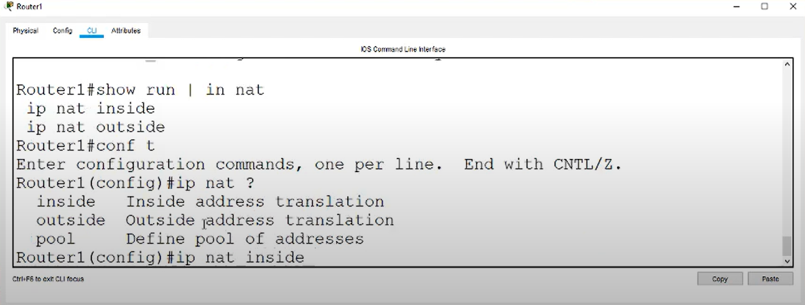

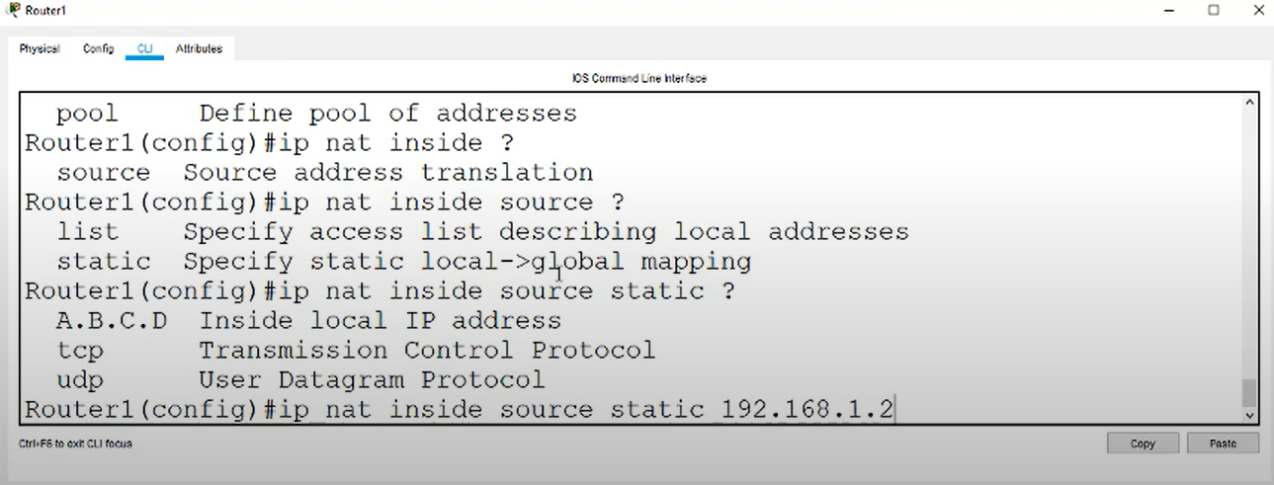

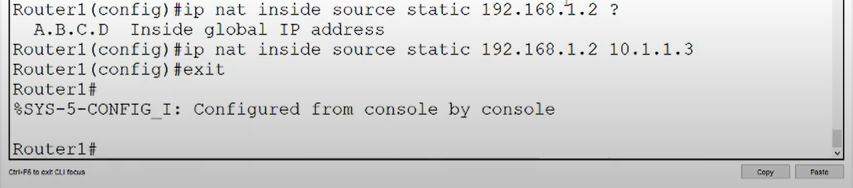

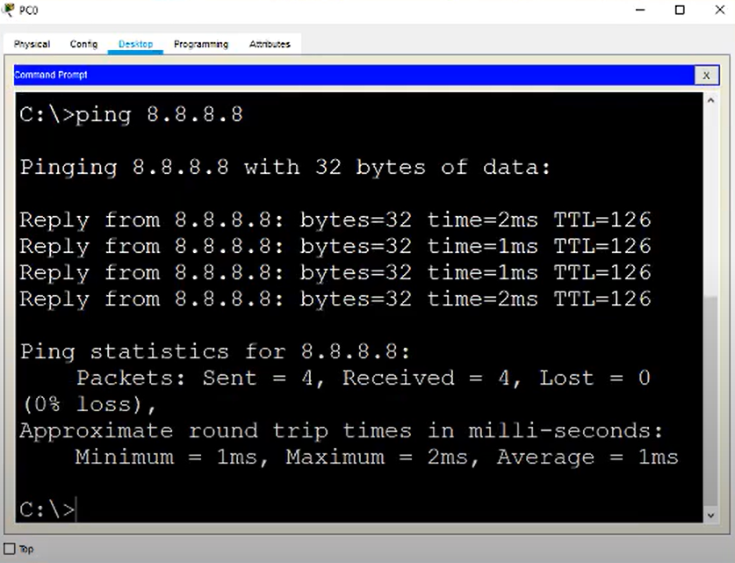

**DYNAMIC NAT**

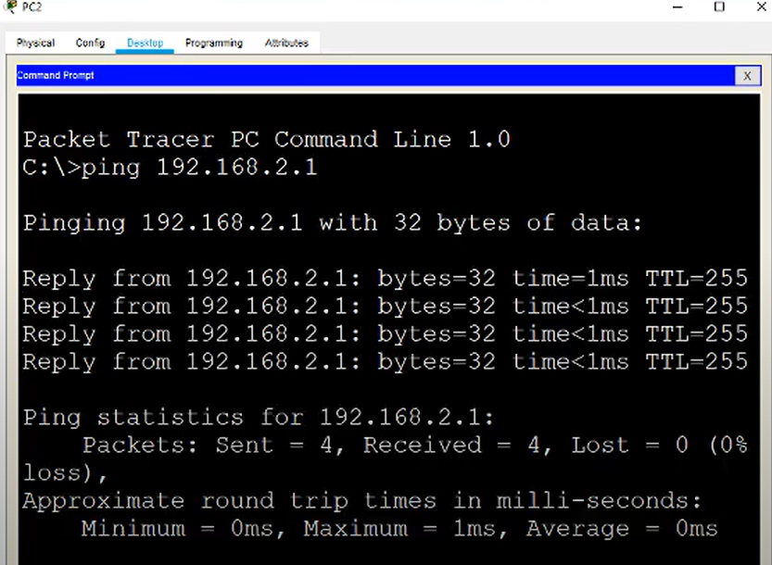

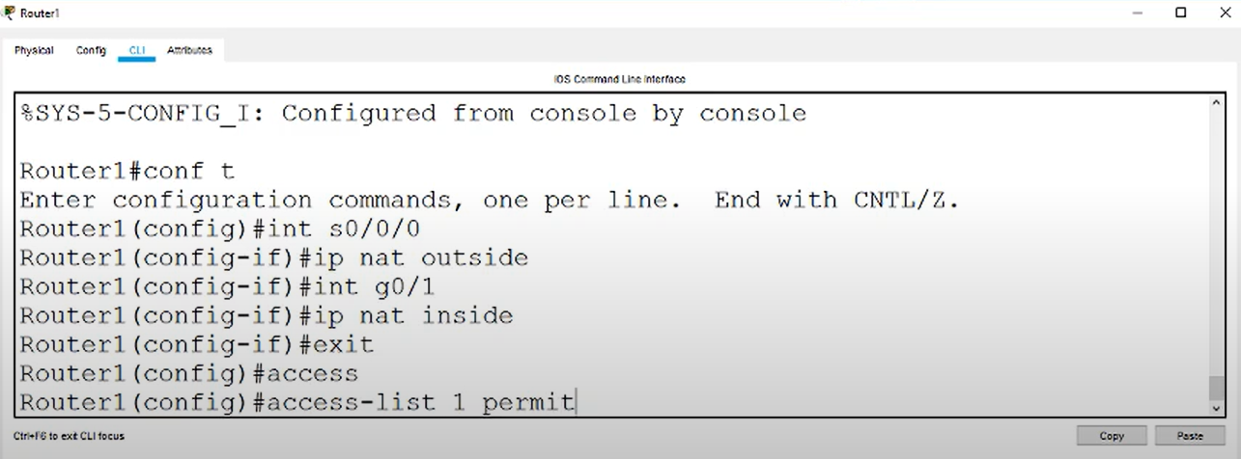

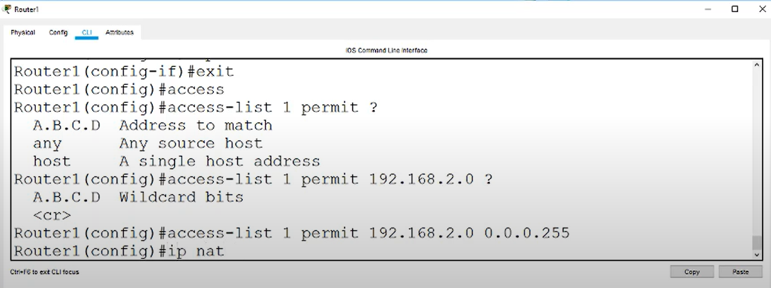

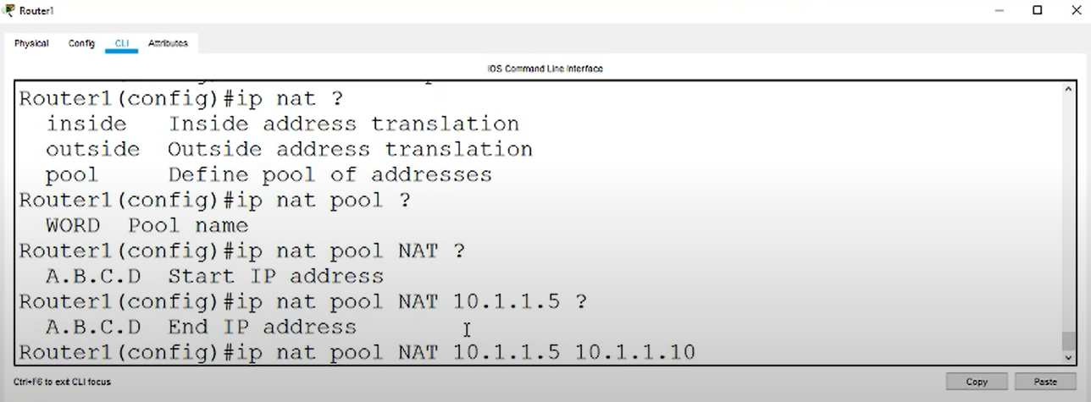

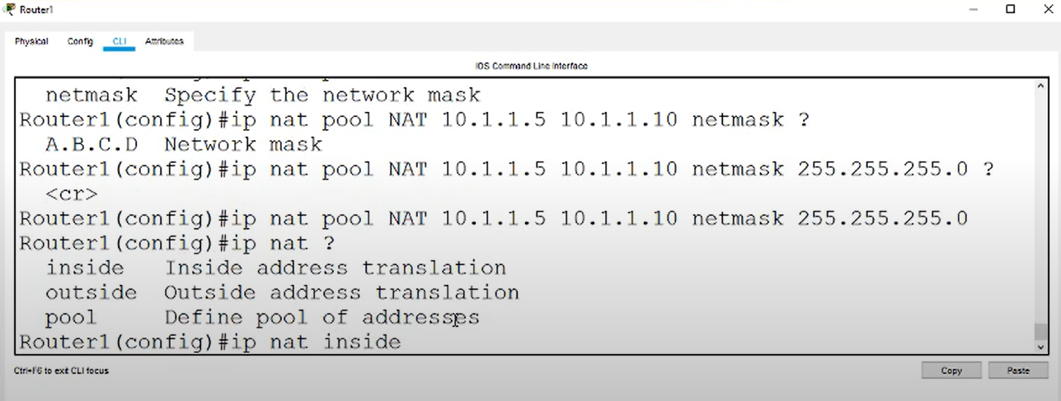

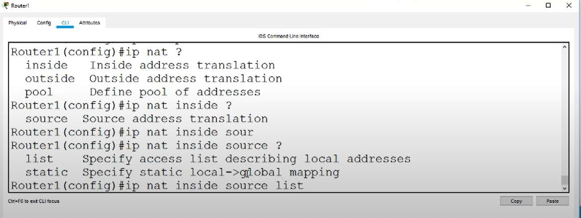

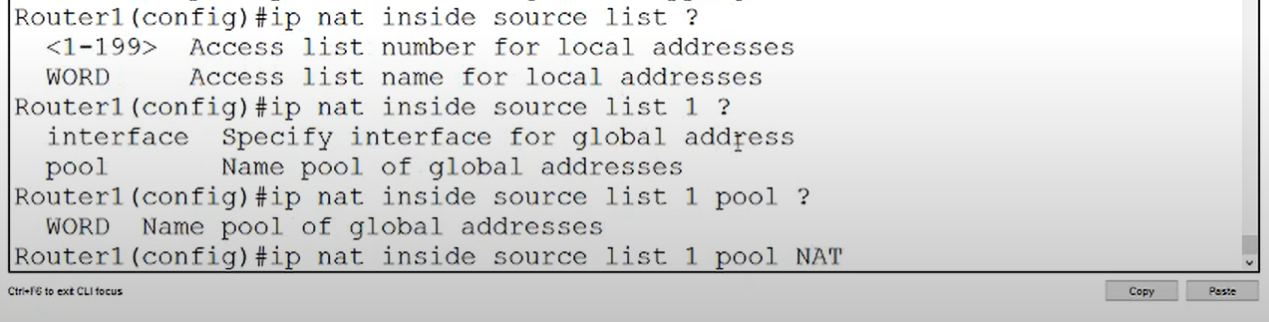

When we put public address from pc0 it gets translated and displays honeypot

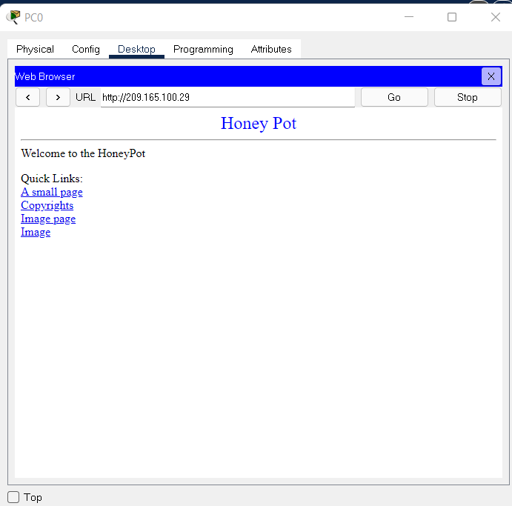

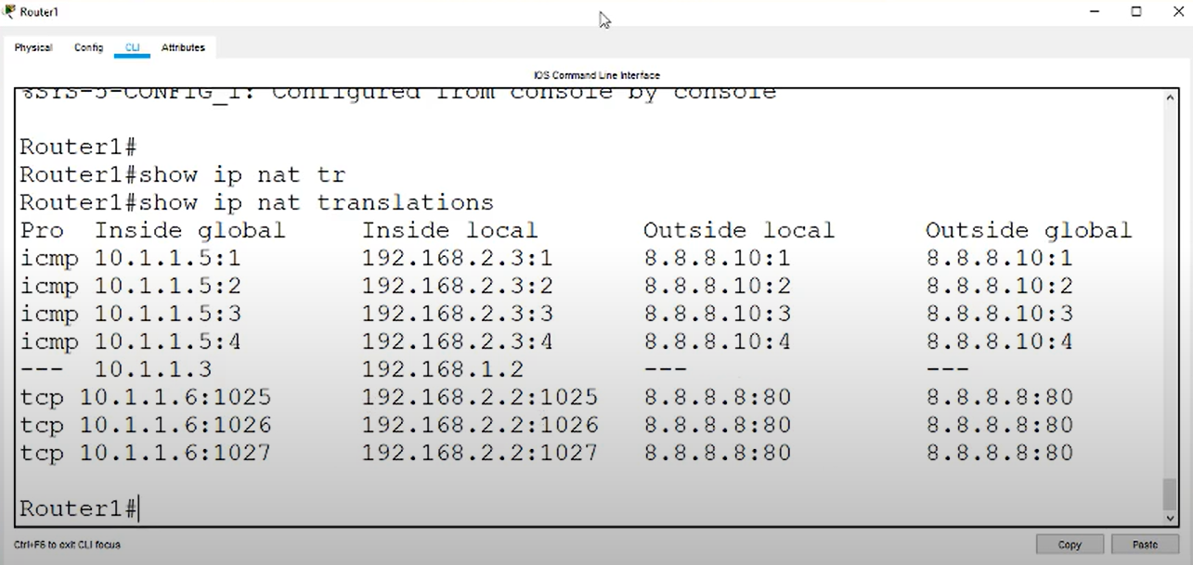

**PAT (Network Overload Translation)**

To translate any computer’s ip address across the network of 192.168.1.0

We use PAT.

Commands

access-list 1 permit 192.168.1.0 0.0.0.255

ip nat inside source list 10 interface g0/0 overload

**Port Address Translation**

Now we want the server to be only available for port 80.

Earlier there was just static translation over all ports but now we will restrict it to only port 80.

**Commands**

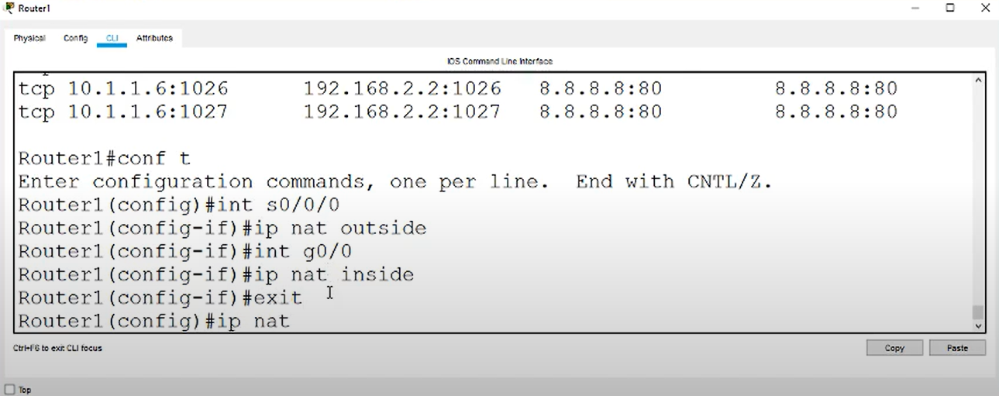

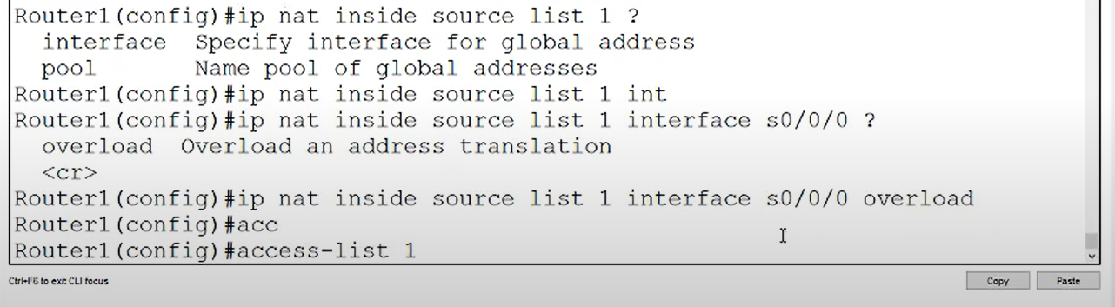

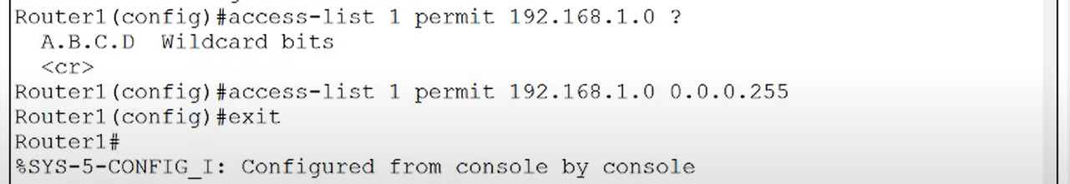

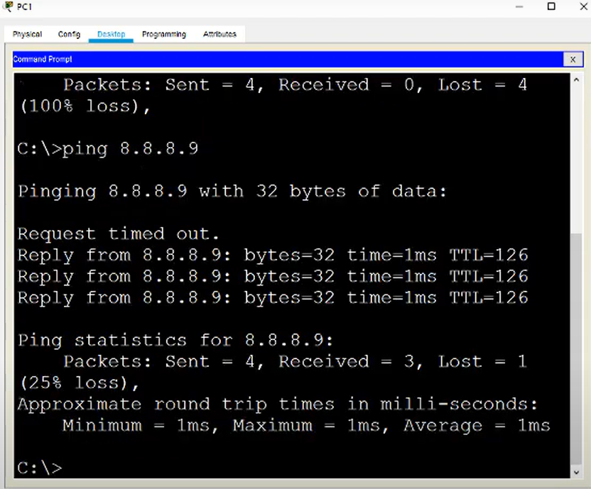

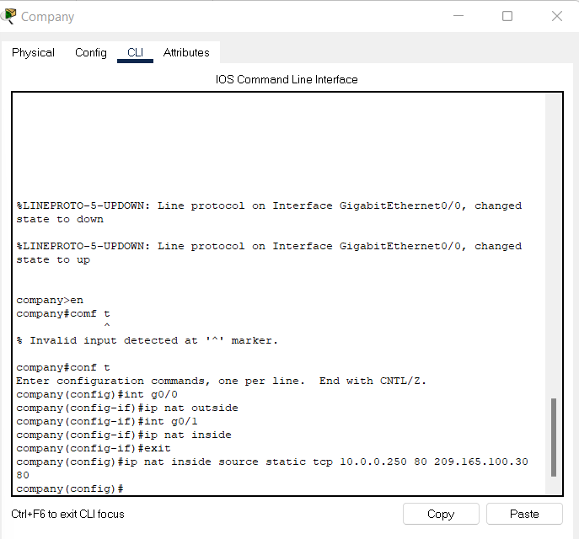

On typing ip address it hits other web server and displays output

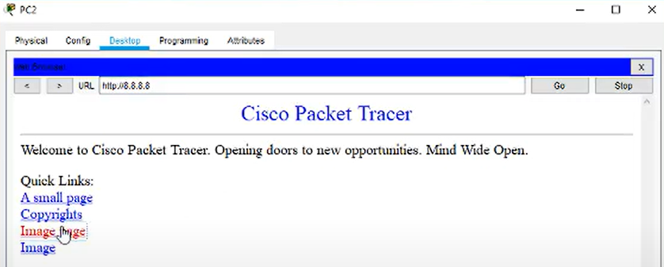

This was the port forwarding to 10.0.0.250 port 80